**CONTENTS**

**1. INTRODUCTION 3**

1.1. SYNOPSIS 4

1.2. ABOUT THE PROJECT 4

**2. TOOLS AND PLATFORM 6**

2.1. LANGUAGE 7

2.2. PLATFORM 12

**3. ORGANIZATION PROFILE 14**

**4. SYSTEM STUDY 16**

4.1. EXISTING SYSTEM 18

4.2. DRAWBACKS OF EXISTING SYSTEM 18

4.3. PROPOSED SYSTEM 18

4.4. ADVANTAGES OF PROPOSED SYSTEM 19

**5. SYSTEM ANALYSIS 20**

5.1. FEASIBILITY STUDIES 21

5.1.1. TECHNICAL FEASIBILITY 21

5.1.2. ECONOMICAL FEASIBILITY 22

5.1.3. OPERATIONAL FEASIBILITY 22

**6. SYSTEM REQUIREMENT SPECIFICATIONS 23**

6.1. SOFTWARE SPECIFICATION 24

6.2. HARDWARE SPECIFICATION 24

**7. DESIGN TOOL 25**

7.1. DFD – INTRODUCTION 26

7.2. DFD FOR ‘NEWS DAILY’ 28

**8. SYSTEM DESIGN 29**

8.1. INPUT DESIGN 30

8.2. OUTPUT DESIGN 30

8.3. DATABASE DESIGN 31

8.4. FORM DESIGN 33

**9. SYSTEM TESTING 34**

9.1. INTRODUCTION 35

9.2. TYPES OF TESTING 36

9.2.1. UNIT TESTING 36

9.2.2. INTEGRATION TESTING 37

9.2.3. SYSTEM TESTING 37

**10. SYSTEM IMPLEMENTATION & MAINTANENCE 38**

**11. CONCLUSION 41**

**12. FUTURE SCOPE 43**

**13. APPENDIX 45**

13.1. SAMPLE CODE 46

13.2. SCREENSHOT 70

**14. BIBILOGRAPHY 76**

**INTRODUCTION**

**1.1 SYNOPSIS**

The project **“NEWS DAILY”** is developing for the common people. It is for the people who are interested in reading the daily news from around the world in different languages.

No formal knowledge is needed for the user to use this system. It is very easy now to read the daily news in all the desired languages whenever and wherever we wish to read. It was a bit difficult task to get the news in different languages whenever we wish.

In this project the aim is to create a computerized program to get all the latest news in different languages by different publishers in a single program. We can computerize this to overcome these problems that are the aim to make the news available for the people in a much more comfortable platform.

**“NEWS DAILY”** is an applicationpackage for the purpose of presenting the latest news all around the world in many different languages form many different publishers in a single platform.

The objective of this project is to make the different new platform to everyone for free which will reduce the cost and time they spend in the earlier days.

We are developing this system using Angular JS in the Windows 10 operating system. This modular program will keep all the detailed latest news in and around the world avalible to the peoples who desires it.

**1.2 ABOUT THE PROJECT**

We are living in an information age depend upon digital information. Digital information is electronic information, the result of computer processing. Every type of job relies upon getting information, using it, and relying information to others. Computers enable the efficient processing and storage of information.

Computers work through an interaction of hardware and software. Hardware refers to the parts of a computer that you can see and touch, including the case and everything inside it. The ability to analyze the problems and to image the development of a complex computer based system in an environment where information resources are proliferating are the challenges that accompany the opportunities of the future.

The main features of this project are:

* Speed of response
* Easy to use
* Save time
* Accuracy
* Easy to record
* Storage
* Versatility
* Diligence

Our project **“NEWS DAILY”** is the software developed for the people in an easy way. Computerization makes things working very efficiently and accurate. The system is fully menu driven. This application program is efficient, user-friendly, and error free and provides a suitable and creative implementation of the system.

**TOOLS AND PLATFORM**

**2.1. LANGUAGE**

* **ANGULAR JS**

AngularJS is a structured, JavaScript framework used for dynamic one-page applications. Being a framework it uses code templates written in HTML in order to perform particular function or command. The data binding and dependency functionalities of Angular JS saves time invested in writing lengthy codes. All these features are packaged in a browser that makes it a suitable server technology.

There is a considerable difference between the Static documents and dynamic applications. Dynamic applications typically use a library and a framework that supports creating web apps. While the library contains a number of functions used to perform certain operations, framework automatically takes the data and calls the functions when needed. However Angular JS creates new HTML constructs that eventually eliminates this mismatch effectively. It creates new syntax with the help of directives.

**General Features**

The general features of AngularJS are as follows −

* AngularJS is a efficient framework that can create Rich Internet Applications (RIA).
* AngularJS provides developers an options to write client side applications using JavaScript in a clean Model View Controller (MVC) way.
* Applications written in AngularJS are cross-browser compliant. AngularJS automatically handles JavaScript code suitable for each browser.
* AngularJS is open source, completely free, and used by thousands of developers around the world. It is licensed under the Apache license version 2.0.

Overall, AngularJS is a framework to build large scale, high-performance, and easyto-maintain web applications.

**Core Features**

The core features of AngularJS are as follows −

* **Data-binding** − It is the automatic synchronization of data between model and view components.
* **Scope** − These are objects that refer to the model. They act as a glue between controller and view.
* **Controller** − These are JavaScript functions bound to a particular scope.
* **Services** − AngularJS comes with several built-in services such as $http to make a XMLHttpRequests. These are singleton objects which are instantiated only once in app.
* **Filters** − These select a subset of items from an array and returns a new array.
* **Directives** − Directives are markers on DOM elements such as elements, attributes, css, and more. These can be used to create custom HTML tags that serve as new, custom widgets. AngularJS has built-in directives such as ngBind, ngModel, etc.
* **Templates** − These are the rendered view with information from the controller and model. These can be a single file (such as index.html) or multiple views in one page using *partials*.
* **Routing** − It is concept of switching views.
* **Model View Whatever** − MVW is a design pattern for dividing an application into different parts called Model, View, and Controller, each with distinct responsibilities. AngularJS does not implement MVC in the traditional sense, but rather something closer to MVVM (Model-View-ViewModel). The Angular JS team refers it humorously as Model View Whatever.
* **Deep Linking** − Deep linking allows to encode the state of application in the URL so that it can be bookmarked. The application can then be restored from the URL to the same state.
* **Dependency Injection** − AngularJS has a built-in dependency injection subsystem that helps the developer to create, understand, and test the applications easily.

**Concepts**

The following diagram depicts some important parts of AngularJS which we will discuss in detail in the subsequent chapters.

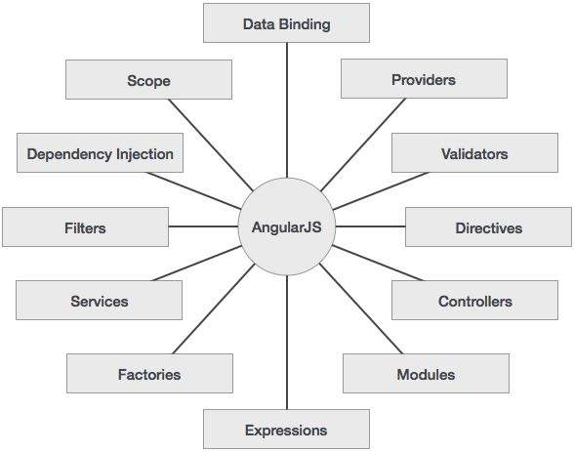

Advantages of AngularJS

The advantages of AngularJS are −

* It provides the capability to create Single Page Application in a very clean and maintainable way.
* It provides data binding capability to HTML. Thus, it gives user a rich and responsive experience.
* AngularJS code is unit testable.
* AngularJS uses dependency injection and make use of separation of concerns.
* AngularJS provides reusable components.
* With AngularJS, the developers can achieve more functionality with short code.
* In AngularJS, views are pure html pages, and controllers written in JavaScript do the business processing.

On the top of everything, AngularJS applications can run on all major browsers and smart phones, including Android and iOS based phones/tablets.

**M**odel **V**iew **C**ontroller or MVC as it is popularly called, is a software design pattern for developing web applications. A Model View Controller pattern is made up of the following three parts −

* **Model** − It is the lowest level of the pattern responsible for maintaining data.
* **View** − It is responsible for displaying all or a portion of the data to the user.
* **Controller** − It is a software Code that controls the interactions between the Model and View.

MVC is popular because it isolates the application logic from the user interface layer and supports separation of concerns. The controller receives all requests for the application and then works with the model to prepare any data needed by the view. The view then uses the data prepared by the controller to generate a final presentable response. The MVC abstraction can be graphically represented as follows.

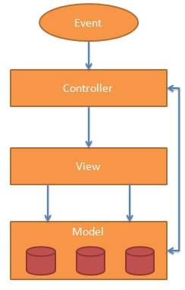

**The Model**

The model is responsible for managing application data. It responds to the request from view and to the instructions from controller to update itself.

**The View**

A presentation of data in a particular format, triggered by the controller's decision to present the data. They are script-based template systems such as JSP, ASP, PHP and very easy to integrate with AJAX technology.

**The Controller**

The controller responds to user input and performs interactions on the data model objects. The controller receives input, validates it, and then performs business operations that modify the state of the data model.

AngularJS is a MVC based framework. In the coming chapters, we will see how AngularJS uses MVC methodology.

**JSON SERVER**

JSON or JavaScript Object Notation is a lightweight text-based open standard designed for human-readable data interchange. Conventions used by JSON are known to programmers, which include C, C++, Java, Python, Perl, etc.

* JSON stands for JavaScript Object Notation.
* The format was specified by Douglas Crockford.
* It was designed for human-readable data interchange.
* It has been extended from the JavaScript scripting language.
* The filename extension is **.json**.
* JSON Internet Media type is **application/json**.
* The Uniform Type Identifier is public.json.

**Uses of JSON**

* It is used while writing JavaScript based applications that includes browser extensions and websites.
* JSON format is used for serializing and transmitting structured data over network connection.
* It is primarily used to transmit data between a server and web applications.
* Web services and APIs use JSON format to provide public data.
* It can be used with modern programming languages.

**Characteristics of JSON**

* JSON is easy to read and write.
* It is a lightweight text-based interchange format.
* JSON is language independent.

**FIREBASE**

Firebase is a backend platform for building Web, Android and IOS applications. It offers real time database, different APIs, multiple authentication types and hosting platform. This is an introductory tutorial, which covers the basics of the Firebase platform and explains how to deal with its various components and sub-components.

# Audience

This tutorial is directed towards developers in need for a simple, user-friendly backend platform. After you finish this tutorial, you will be familiar with the Firebase Web Platform. You can also use this as a reference in your future development.

This tutorial is intended to make you comfortable in getting started with the Firebase backend platform and its various functions.

# Prerequisites

You will need some JavaScript knowledge to be able to follow this tutorial. Knowledge about some backend platform is not necessary, but it could help you to understand the various Firebase concepts.

**2.2. PLATFORM**

**Operating System: Windows** 10.0

Windows 10.0 is a line of operating systems produced by Microsoft for use on personal computers, including home and business desktops, laptops, and media centers. Windows 10.0 is the successor to both Windows 9 and other Windows OS.

**Features of Windows** 8.0

Windows 8.0 introduced several new features to the Windows line, including,

* Faster start-up and hibernation sequences.
* The ability to discard a newer device driver in favor of the previous one (known as driver rollback), should a driver upgrade not produce desirable results.
* A new, arguably more user-friendly interface, including the framework for developing themes for the desktop environment.
* Fast user switching, which allows a user to save the current state and open applications of their desktop and allow another user to log on without losing that information.
* The Clear Type font rendering mechanism, which is designed to improve text readability on Liquid Crystal Display (LCD) and similar monitor.

**ORGANIZATION**

**PROFILE**

**ROGERSOFT**

**Address :**NS Building,2nd Floor

Opposite civil station

**Location :**Kakkanad - Kochi-Cochin

**Postal Code :**682030

**Phone :**99956 38376

**Mobile :** 9497703076

**Enquiry (24/7):**80941 56781

**Website:**www.rogersoft.com

**Landmark :**Behind Collectorate Traffic Signal

**Category :**Training Institute

One of the highly recognized training centres in this city, Rogersoft in Kakkanad was established in 2014. It has been playing a pivotal role ever since its establishment by enabling the students to have easy access to rich learning programs. It has been constantly empowering the students by helping them identify the uniqueness of their courses and curriculum while at the same time making them understand as to how to use these courses to their best advantage. The establishment is run by a team of qualified and professional people, having enormous industry knowledge and skills. The locality around is well-connected with different parts of the city due to which accessing the institute is a convenient affair. This listing is also listed in Computer Training Institutes.

**SYSTEM STUDY**

A system is an orderly grouping of interdependent components linked together according to a plan to achieve a specific objective. That is a system is a combination of resources working together to convert inputs into useful outputs. The resources used by a system include personal facilities and lateral equipments.

System study is a detailed study of various operations performed by a system and their relationship with in and outside it is an orderly process for identifying and solving problems. System study is done in order to understand the problem and emphasize what is needed from the system. The system study involves studying and analyzing the way the organization currently retrieves and process data to produce information with goal of determining how to make it better. In this step, the main task understands the need of system. The information requirements of the users are also determined in this phase. It can be done on an existing system only. The various techniques used in this are:

* **Observation**

The observation of the functioning of the system that exists gives the idea for the design of the new system. It is helpful to understand and study entire current system.

* **Interviews**

The main objective is to obtain information regarding system from the concerned exclusive to understand the system requirements and they are to improve the existing system.

* **Discussion**

Discussion goes a long way in satisfying the needs of the College. The objective of the discussion is transferring the ideas between department and the system developer. Through discussion useful suggestions made by the user can be in corporate into the new system.

**4.1. EXISTING SYSTEM**

The existing system is manual one and there are also various online news applications are available. That are time consuming, less accurate and mistake may be come. The objective of new system is to make the different variety of news in different languages form various sources make available in single destination. The older days people needed to read different kinds of newspaper to different kinds of news form different sources. When using the newspaper media the latest updation of news is not possible. Also the news applications that are available now a days don’t contain news from the various destinations/channels.

The main limitation of this system is that it is time consuming process to find out all the news needed form the different sources and languages.

**4.2. DRAWBACKS OF EXISTING SYSTEM**

The limitations of the existing systems are listed out below:

* Reading news from different channels at the same time is difficult.
* No authorization is needed.
* Time consuming.
* Detailed news reading is difficult.
* News in different languages are different to find at a single source.
* Less efficient

**4.3. PROPOSED SYSTEM**

The primary objective of the proposed system design is to overcome the drawbacks of the existing system and reduce the manual work. We can achieve this objective by computerizing the whole activities that are carried out manually. Computerization will reduce manual work and produce desired information efficiently and quickly.

In manual system the collection of the news from different sources in different language is a bit difficult and time consuming process. The collection of the news from different sources in different language is made more easy by the proposed system. The proposed system gives the user all the latest news form various destinations like the BBC news, GOOGLE news, IGN, etc that too in different kinds of international languages.

The system is:

* User friendly
* It assist the user with respective messages to overcome three errors at run time
* This may also help the end user to obtain necessary information
* Efficient efforts are taken to reduce data redundancy
* System takes care of this situations and produces timely reports

**4.4 ADVANTAGES OF PROPOSED SYSTEM**

* Fast, Powerful, Simple and Integrated.
* Faster and more accurate retrieval of information
* News from different destinations can be viewed easily.
* More efficient in processing of information.
* Creates a more user friendly environment
* Reduce chance of errors
* Cost of establishment and maintenance is relatively low.
* Time delay for any process is reduced
* News in various language is available easy.
* Unauthorized access is not possible

**SYSTEM ANALYSIS**

A system is an orderly grouping of interdependent components liked together according to a plan to achieve a specific objective. That is a system is a combination of resources working together to convert input into useful outputs. The resources used by a system include personal facilities and lateral equipments.

Analysis is the detailed study of various operations performs by the system and their relationships, available files, decision points and transactions handled by the present system. Training, experience and commonsense are required for collection of information needed to do the analysis.

System analysis is a general term that refers to an orderly structured process for identifying and solving problems. We call the system analysis process, the life cycle methodology, since it relates to our significant phases in the life cycle of all business information system. The definition of system analysis include not only the process of analysis, but also that of synthesis, which is the process of put in parts together to form a new system.

**5.1 FEASIBILITY STUDY**

Preliminary investigation examine project feasibility, the like hood system organization. All projects are feasible-given unlimited resource and infinite time. Unfortunately, the development of a computer-given unlimited resources and difficult delivery dates. It is both necessary and prudent to evaluate the feasibility of the projects at earliest possible time. Feasibility and risk analysis are related in many ways. Important tests of feasibility are studied and described below.

**5.1.1 TECHNICAL FEASIBILITY**

There are a number of technical issues, which are generally raised during the feasibility stage of the investigation. A study of function, performance and constraints that may affects the ability to achieve an acceptable system.

The considerations that are normally associated technical feasibility include:

* Development risk
* Resource availability
* Technology

**5.1.2 ECONOMIC FEASIBILITY**

Economic feasibility is an important task of system analysis. A system that can be developed technically and that will be used if installed must still be profitable for the organization. Financial benefits must equal or exceeds the cost. The analysis raises financial and economic questions during the preliminary investigation to estimate the following:

* The cost to conduct a full systems investigation
* The cost of hardware and software for the class of application of the project being considered
* The benefit in the form of reduced costs or fewer costly errors
* The cost if nothing changes
* To be judged feasible, a proposal for the specific project must pass these tests; otherwise it is considered as a feasible project.

In the existing system, many people are involved in the process but in the proposed system, number of persons involved be reduced drastically. So the proposed system is economic.

**5.1.3 OPERATIONAL FEASIBILITY**

The hierarchy of the new system is very easier than the existing system. The new system is very much easier and user friendly. Optional cost is bearable. The operation with the new system is very easy. The maintenance and modification of the new system needs very less human effort. Using command buttons throughout the application programs enhances the operational feasibility.

**REQUIREMENT**

**SPECIFICATION** 

**6.1. SOFTWARE SPECIFICATION**

Operating System : Windows XP

Language used : Angular JS

**6.2. HARDWARE SPECIFICATION**

Processor : Intel Celeron or higher

RAM : 128 MB or more

Hard Disk : 40 GB or more

**DESIGN TOOL**

**7.1 DATA FLOW DIAGRAMS**

A Data Flow Diagram (DFD) is a graphical representation of the "flow" of data through an [information system.](http://en.wikipedia.org/wiki/Information_system) A data flow diagram can also be used for the [visualization](http://en.wikipedia.org/wiki/Visualization) of [data processing](http://en.wikipedia.org/wiki/Data_processing) .Data Flow Diagram is common practice for a designer to draw a [context-level Data flow diagram](http://en.wikipedia.org/wiki/System_context_diagram) first which shows the interaction between the system and o utside entities.

The DFD is designed to show how a system is divided into smaller portions and to highlight the flow of data between those parts. This context-level Data flow diagram is then "exploded" to show more detail of the system being modeled. Data flow diagrams were invented by [Larry Constantine,](http://en.wikipedia.org/wiki/Larry_Constantine) the original developer of structured design, based on Martin and Estrin's "data flow graph" model of computation.

A Data Flow Diagram is a network that describes the flow of data and processes that change, or transform, data throughout the system. This network is constructed by using a set of symbols that do not imply a physical implementation. It is a graphical tool for structured analysis of the system requirements. DFD models a system by using external entities from which data flows to a process, which transforms the data and creates, output-data-flows which go to other processes or external entities or files. Data in files may also flow to processes as inputs.

There are various symbols used in a DFD. Bubbles represent the processes. Named arrows indicate the data flow. External entities are represented by rectangles and are outside the system such as venders or customers with whom the system interacts. They either supply or consume data. Entities supplying data are known as sources and those that consume data are called sinks. Data are stored in a data store by a process in the system. Each component in a DFD is labeled with a descriptive name. Process names are further identified with a number.

DFDs can be hierarchically organized, which help in partitioning and analyzing large systems. As a first step, one Data Flow Diagram can depict an entire system, which gives the system overview. It is called Context Diagram of level 0 DFD. Thus successive expansion of a DFD from the Context Diagram to those giving more details is known as leveling of DFD. Thus a top down approach is used, starting with an overview and then working out the details.

The Data Flow Diagram shows the logical flow of a system and defines the boundaries of the system. For a candidate system, it describes the inputs (source), outputs (destination), database (files) and procedures (data flow), all in a format that meet the user’s requirements. The main merit of DFD is that it can provide an

overview of system requirements, what data a system would process, what transformations of data are done, what files are used, and where the results flow.

In the normal convention a DFD has four major symbols

Square, this defines source or destination of data



Arrow, this shows data flow

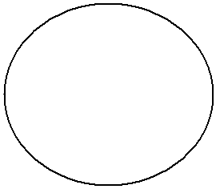

Circle, this represents a process that transforms incoming data into outgoing flow

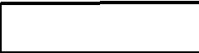

Open rectangle, this shows a data store

**7.2. DFD FOR ‘NEWS DAILY’**

LEVEL 0

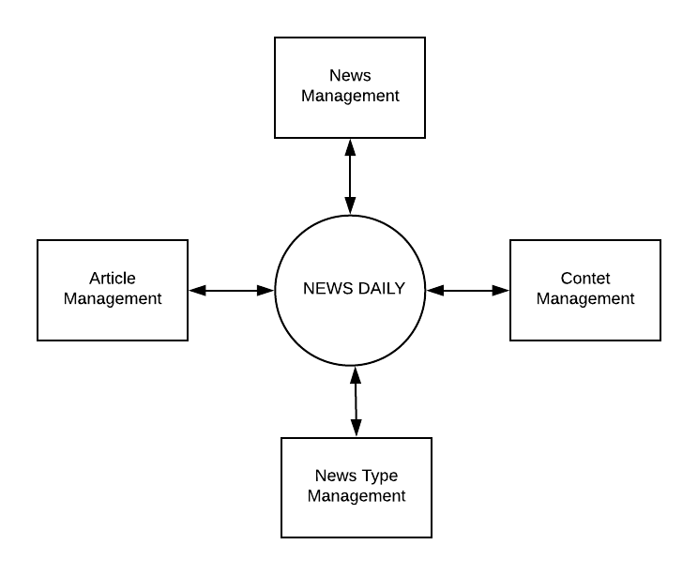

**SYSTEM DESIGN**

The goal of software design is to produce a model or representation of an entity that will be built later. Hence three types of design are used

* Input design
* Output design
* Database design
* Form Design

**8.1 INPUT DESIGN**

The user should not be subjected to fatigue. The user will be driven to boredom very soon, if the user interface is hard to work. So the user interface is also an important phase in system design.

Much of the user’s time is spend in picking commands, typing data and providing system input. Since many input will automatically displayed for one particular input changed, the computerized Home Appliances shop management system is very easy to operate. For these features are used:

o The number of input action are minimized.

o The users are followed to customize input.

o Interactions are flexible.

**8.2 OUTPUT DESIGN**

The output design, an ongoing activity almost from the beginning of the project, follows the principle of the form design. Output design is the processing of converting data into labels from a computer-based system into a detailed description of data in the form of screens. Users can browse through can be used for future reference.

The CRT display can include a little, column headings, detailed data total; they must be described in details for programmers. In case of CRT displays layout design the area is limited by the size of the screen as the amount of data can be displayed in a records.

**8.3 DATABASE DESIGN**

The most important aspect of building an application is the design of tables or the database schema. The data stored in the tables must be organized in some manner, which is meaningful. The overall objective in the process of table design has been to treat data as an organizational, resource and as an integrated whole. The organization of data in a database aim to achieve three major objectives, which are given below,

• Data integration

* Data abstraction
* Data independence

Several degrees of normalization have to be applied during the process of table design. The major aim of the process of normalization is to reduce data redundancy and prevent losing data integrity. Data integrity has to be converted at all levels. Pure normalization can access problem related to storage and retrieval of data. During the process of normalization, dependence’s can be identified which cause serious problems during deletion and updating. Normalizing also hope in simplifying the structure of table.

The theme behind a database is to handle information as an integrated whole thus making access to information easy, quick, inexpensive and flexible for users.

The entire package depends on how the data are maintained in the system. Each table has been designed with a perfect vision.

Minor tables have been treated which through takes much space facilitates the process of querying fast and accurate.

**What is Normalization?**

Normalization is the process of efficiently organizing data in a database. There are two goals of the normalization process: eliminating redundant data (for example, storing the same data in more than one table) and ensuring data dependencies make sense (only storing related data in a table). Both of these are worthy goals as they reduce the amount of space a database consumes and ensure that data is logically stored.

**The Normal Forms**

The database community has developed a series of guidelines for ensuring that databases are normalized. These are referred to as normal forms and are numbered from one (the lowest form of normalization, referred to as first normal form or 1NF) through five (fifth normal form or 5NF).

In the proposed system you’ll only see 1NF.

First normal form (1NF) sets the very basic rules for an organized database:

A relation is said to be in 1NF if and only if every entry of the relation has at most a single value. All columns contain atomic values or a single value only.

**First Normal Form**

A relation is in first normal form (1NF) if and all its attributes are based on single domain. The objective of normalizing a table is to remove its repeating groups and ensure that all entries of the resulting table have at most single value.

**Second Normal Form**

A table is said to be second Normal Form (2NF), when it is in 1NF and every attribute in the record is functionally dependent upon the whole key, and not just a part of the key.

**Benefits:**

1. Eliminate data redundancy
2. Improve performance
3. Query optimization
4. Faster update due to less number of columns in one table.
5. Index improvement

**RULES OF NORMALIZATION**

Rule 1: There should be a one-to-one relationship between the instances of an entity and rows of the table.

Rule 2: A field should have the same meaning in each row of the table.

Rule 3: Each table should represent at most one entity.

Rule 4: Multiple instances of an entity should be represented by multiple rows in a table.

Rule 5: Joins should be based only on primary and foreign-key equality.

Rule 6: Make sure keys are linked correctly.

**8.4. FORM DESIGN**

One of the greatest benefits we have seen when creating single page applications with AngularJS is how much faster and easier it is to design forms, even those with complex validation.

This will be a multi-part series covering all the best practices we have picked up when designing HTML forms. Part 1 will provide step by step instructions for building a simple and user-friendly contact information form with AngularJS.

This series assumes some level of AngularJS familiarity, but is intended for novices and veterans alike. I will be including links to the concepts that might be unfamiliar to beginners.

**SYSTEM TESTING**

**9.1 INTRODUCTION**

The purpose of the system testing is to identify and correct errors in the candidate system. Testing is an important element of the software quality assurance and represents the ultimate review of specification, design and coding. The increasing visibility of the software as a system element and the costs associated with a software failure are motivated forces for well planned through testing.

Software testing is a critical element of software quality assurance and represents the ultimate quality review of specifications, design and code generation. Once the source code has been generated, the program should be executed before the customer gets it with the specific intend of finding and removing all errors, test must be designed using disciplined techniques. Testing technique provides the systematic guidance for designing tests. To uncover the errors in the program behavior function and performance the following steps to be done:

* Execute the integral logic of the software components.
* Execute the input and output domains of the program to uncover errors.
* During testing the system is used experimentally to ensure that the software does not fail, i.e., it will run according to the specification and in the way the user exports.
* Preparation of test data plays n vital rule in the system testing. Different set of test data are generated and the sy7stem under study is tested using that data.
* While testing using test data errors are again uncovered and corrected using different testing techniques.

System testing was conducted in order to detect errors and for comparing then the final system with the requirement specification report. That is, whether the system meets requirements. During testing the software was executed with a set of test cases and the output of the program for the test cases was evaluated to determine if the program is performing as it was expected to.

Testing presents, an interesting challenge for the software engineer attends to hold software from an abstract concept to an acceptable implementation. In testing engineer creates a series of test cases that occurs when errors are uncovered. Testing is the process of executing a program for finding errors. A good test is one that has high probability of finding an uncovered error.

The turn error is used to refer the difference between the actual output of the software to fail to perform its required function. Software reliability is defined as the required function. Software reliability is defined as the probability that the software will not undergo failure for a specified time under specified condition. Failure is the inability of a system or a component to perform a required function according to its specification. Different levels of testing were employed for software to make an error free, fault free and reliable. Basically in software testing three type of testing methods are adopted.

* Unit testing
* Integration testing
* System testing

**9.2 TYPES OF TESTING**

* **UNIT TESTING**

In unit testing the analysis tests the programs making a system. Unit testing gives stress on the modules independently of one another, to find errors. This helps the tester in detecting errors in coding and logic that are within that module alone. The errors resulting from the interaction between modules are initially avoided. Unit testing can be performed from the bottom up, starting with smallest and lowest-level modules and proceeding one at a time. For each module in bottom-up testing a short program is used to execute the module and provides the needed data, so that the module is asked to perform the way it will when embedded within the larger system.

Unit testing deals with testing a unit testing a unit as a whole. This would test the interaction of many functions but confine the test within one unit. The exact scope of a unit is left to interpretation. Supporting test code, sometimes called scaffolding, may be necessary to support an individual test. This type of testing is driven by the architecture and implementation teams. This focus is also called back-box testing because only the details of the interface are visible to the test. Limits that are global to a unit are tested here.

In software testing, one particular test may need some supporting software. This software established an environment around the test. Only when this environment is established can a correct evolution of the test take place. The scaffolding software may establish state and values for data structures as well as providing dummy external functions for the test. Different scaffolding software rarely is considered part of the system.

Sometimes the scaffolding software becomes larger than the system software being tested. Usually the scaffolding software is not of the same quality as the system software and frequently is quite fragile. A small change in the change may much larger changes in the scaffolding.

* **INTEGRATION TESTING**

This testing level can be simply defined as integrating and then testing i.e.,here, many unit tested modules are combined into subsystems, which are then tested. Integration testing aims at whether the modules can be integrated properly. Hence, the emphasis is on testing interfaces between modules. This testing activity can be considered testing the design.

* **SYSTEM TESTING**

The important and essential part of the system development phase, after designing and developing the software is system testing. Theoretically, a newly designed system should have all the parts or sub systems are in working order, but in reality, each sub-system into one pool and test the whole system to determine whether it meets the user requirements. This is the last change to detect and correct errors before the system is installed for user acceptance testing. The purpose testing is to consider all the likely variations to which it will be subjected and then push the system to its limits.

**IMPLEMENTATION**

**AND**

**MAINTENANCE**

Implementation is the stage of the project when the theoretical design is turned into a working system. The implementation stage is a systems project in its own right. It includes careful planning, investigation of current system and its constraints on implementation, design of methods to achieve the changeover.

The first task in implementation is planning-deciding on the methods and time-scale to be adopted. Once the planning has been completed, the major effort is to ensure that the programs in the system are working properly.

When the Transport service system is linked to terminals on remote sites, the telecommunication network and tests of the network along with the system are also include under implementation. The initial parameters of the management information system should be modified as a result of programming efforts; programming provides a reality test for the assumption made by the analyst.

System testing check the readiness and accuracy of the system access update and retrieve data from new files. Once the program becomes available, the test data are read into the computer and processed. In this system, conventional Parallel Run was conducted to establish the efficiency of the system.

Implementation is used here to mean the process of converting a new or a revised system design into an operational one. Conversion means changing from one system to another. The objective is to put the tested system into operation while holding costs, risks, and personal irritation to a minimum.Changeover is the process of adopting the new system. The new system has to be introduced however. This is done after the system has been developed and tested completely. There is a set of methods like Direct Changeover, Parallel Changeover, Pilot running etc. Pilot running is intended here.

Data from one or more previous periods for the whole or part of the system is run on the new system after results have been obtained from the old system and both are compared. It is performed till the completion of one system life cycle.

When the changeover has taken place there will be a need for amendment to correct or improve the new system. When the user wants to add system and both are compared. It is performed till the completion of one system life cycle.

Maintenance activity may require the continuing involvement of a large proportion of computer department resources. For computer installations, which have already developed the basic applications for the organization, the main task may be to adapt existing system in a changing environment. Perhaps a better term to describe this activity is system evolution. All systems are dynamic and subject to constantly changing requirements. Efforts must be developed to adapting them and design should be flexible specified so that such changes are easily implemented. Most changes arise in two ways. As part of the normal running of the system when errors are found, users ask for improvement or external requirements change and as result of specific investigation and review of system’s performance.

**CONCLUSION**

I put as much as effort to develop this application titled “**NEWS DAILY**” thatis easily accessible, informative andhelpful. It has been designed for future addition so that any user requirements can be made easily possible. Through the system is working on various assumptions it can be modified easily to any kind of requirements. It has been designed in such a way that it is easy to modify, can be updated efficiently and accurately. The forms are designed user friendly by providing messages and captions whenever necessary.

The developed software meets most of the requirements and every effort has been done to make the system work easier. Once again I would like to thank everyone who was somehow or other related with the successful completion of this project.

**FUTURE SCOPE**

Making enhancement is all about perfective maintenance. It means adding, modifying or redeveloping the code to support changes in the specifications. It is necessary to keep up with changing user needs and the operational environment. More money and times is spent on perfective maintenance than on corrective or adaptive maintenance together. The system has been designed in such a way that it can be modified with very little effort when such needs arise in the future. New features can be added with slight modifications of software which make it easy to expand the scope of this project. Though the system is working on various assumptions, it can be modified easily to any kind of requirements.

In the proposed system “**NEWS DAILY**”, futureenhancements are possible in the following areas:

* Login and news saving option.
* Live news.
* News with audio and video.

**APPENDIX** **13.1. SAMPLE CODE**

**home.component.html :**

<div class="homebtn" fxLayout="wrap row" fxLayout.xs="column" fxLayoutGap="1%" fxLayoutAlign="center">

<a routerLink="/posts" mat-raised-button color="primary">Choose News Source</a>

</div>

<div class="loader" *ngIf="!((mArticles)?.length > 0)">

<mat-spinner></mat-spinner>

</div>

<div class="container" fxLayout="wrap row" fxLayout.xs="column" fxLayoutGap="1%" fxLayoutAlign="center">

<div *ngFor="let post of mArticles" fxFlex="20%">

<mat-card class=singleNews>

<img mat-card-image src="{{post.urlToImage}}" onError="this.src='../../assets/blank.png';">

<div class="cardbody">

<mat-card-title>{{post.title}}</mat-card-title>

<mat-card-content>

<p>{{post.description}}</p>

</mat-card-content>

</div>

<mat-card-actions align="end">

<button mat-button>SAVE</button>

<button mat-button>SHARE</button>

<a href="{{post.url}}" target="_balnk" mat-raised-button color="accent">Read More</a>

</mat-card-actions>

</mat-card>

</div>

</div>

[**home.component.ts**](http://home.component.ts) **:**

import { Component, OnInit } from '@angular/core';

import { NewsService } from '../services/news.service';

@Component({

selector: 'app-home',

templateUrl: './home.component.html',

styleUrls: ['./home.component.scss'],

providers:[NewsService]

})

export class HomeComponent implements OnInit {

mArticles: Array<any>;

constructor(private newsService: NewsService){}

ngOnInit() {

this.newsService.getTopHeadLines()

.subscribe(

data => {

this.mArticles = data['articles'];

// console.log(this.mArticles);

}

);

console.log('out', this.mArticles);

}

}

**navbar.component,html :**

<mat-toolbar color="primary">

<mat-toolbar-row>

<span>News Daily</span>

<span class="example-spacer"></span>

<a class="example-link" routerLink="/" mat-button>Home</a>

<a class="example-link" routerLink="/posts" mat-button>Posts</a>

<a class="example-link" routerLink="/login" mat-button>Login</a>

<mat-slide-toggle [checked]="isThemeDark | async" (change)="toggleDarkTheme($event.checked)">Dark theme</mat-slide-toggle>

</mat-toolbar-row>

</mat-toolbar>

**navbar.component,ts :**

import { Component, OnInit } from '@angular/core';

import { ThemeService } from '../services/theme.service';

import { Observable } from 'rxjs';

@Component({

selector: 'app-navbar',

templateUrl: './navbar.component.html',

styleUrls: ['./navbar.component.scss']

})

export class NavbarComponent implements OnInit {

isThemeDark: Observable<boolean>;

constructor(private themeService: ThemeService) { }

ngOnInit() {

this.isThemeDark = this.themeService.isThemeDark;

}

toggleDarkTheme(checked: boolean) {

this.themeService.setDarkTheme(checked);

}

}

**posts.component.html :**

<div class="container margin-top" fxLayout="wrap row" fxLayout.xs="column" fxLayoutGap="1%" fxLayoutAlign="center">

<mat-card class="filter">

<form #filternewsForm="ngForm">

<mat-form-field>

<mat-select placeholder="News Source" [(ngModel)]='filterSource' name="source" required>

<mat-option *ngFor="let source of mSources" [value]="source.id">

{{source.name}} - {{ source.language }}

</mat-option>

</mat-select>

</mat-form-field>

<button mat-raised-button color="primary" (click)='filterNews(filterSource)' [disabled]="!filternewsForm.form.valid">Filter News to

<span style="text-transform: capitalize; ">{{filterSource}}</span>

</button>

</form>

</mat-card>

</div>

<div class="loader" *ngIf="!((mArticles)?.length > 0)">

<mat-spinner></mat-spinner>

</div>

<div class="container" fxLayout="wrap row" fxLayout.xs="column" fxLayoutGap="1%" fxLayoutAlign="center">

<div *ngFor="let post of mArticles" fxFlex="20%">

<mat-card class=singleNews>

<img mat-card-image src="{{post.urlToImage}}" onError="this.src='../../assets/blank.png';">

<div class="cardbody">

<mat-card-title>{{post.title}}</mat-card-title>

<mat-card-content>

<p>{{post.description}}</p>

</mat-card-content>

</div>

<mat-card-actions align ="end">

<a href="{{post.url}}" target="_blank" mat-raised-button color="accent">Read More</a>

</mat-card-actions>

</mat-card>

</div>

</div>

**posts.component.ts :**

import { Component, OnInit } from "@angular/core";

import { NewsService } from '../services/news.service';

@Component({

selector: "app-posts",

templateUrl: "./posts.component.html",

styleUrls: ["./posts.component.scss"],

providers:[NewsService]

})

export class PostsComponent implements OnInit {

mArticles: Array<any>;

mSources: Array<any>;

filterSource ='google-news';

constructor(private newsService: NewsService){}

ngOnInit() {

this.newsService.getTopHeadLines()

.subscribe(

data => this.mArticles = data['articles']

);

this.getnewsSources();

}

filterNews(source) {

this.newsService.getNewBySource(source)

.subscribe(

data => this.mArticles = data['articles']

);

}

getnewsSources() {

this.newsService.getSources()

.subscribe(

data => this.mSources = data['sources']

);

}

}

**news.service.ts :**

import { Injectable } from '@angular/core';

import { HttpClient} from '@angular/common/http';

import { environment } from '../../environments/environment';

@Injectable()

export class NewsService {

key = '91339ddcc26e4cb7973d925ca3b216d4';

constructor(private http: HttpClient) { }

getTopHeadLines(){

return this.http.get('https://newsapi.org/v2/top-headlines?country=us&category=business&apiKey=' + this.key);

}

getNewBySource(source){

return this.http.get('https://newsapi.org/v2/top-headlines?sources=' + source + '&apiKey=' + this.key);

}

getSources(){

return this.http.get('https://newsapi.org/v2/sources?apiKey=' + this.key);

}

}

**theme.service :**

import { Injectable } from '@angular/core';

import { Subject } from 'rxjs';

@Injectable()

export class ThemeService {

private _themeDark: Subject<boolean> = new Subject<boolean>();

isThemeDark = this._themeDark.asObservable();

setDarkTheme(isThemeDark: boolean) {

this._themeDark.next(isThemeDark);

}

}

**theme.service.ts :**

import { Injectable } from '@angular/core';

import { Subject } from 'rxjs';

@Injectable()

export class ThemeService {

private _themeDark: Subject<boolean> = new Subject<boolean>();

isThemeDark = this._themeDark.asObservable();

setDarkTheme(isThemeDark: boolean) {

this._themeDark.next(isThemeDark);

}}

**app-routing.module.ts :**

import { NgModule } from '@angular/core';

import { Routes, RouterModule } from '@angular/router';

import { PostsComponent } from './posts/posts.component';

import { HomeComponent } from './home/home.component';

// import { LoginComponent } from './login/login.component';

const routes: Routes = [

{

path: '',

component: HomeComponent

},

{

path: 'posts',

component: PostsComponent

}

];

@NgModule({

imports: [RouterModule.forRoot(routes)],

exports: [RouterModule]

})

export class AppRoutingModule { }

**app.component.ts :**

import { Component, OnInit } from "@angular/core";

import { Observable } from "rxjs";

import { ThemeService } from "./services/theme.service";

@Component({

selector: "app-root",

templateUrl: "./app.component.html",

styleUrls: ["./app.component.scss"]

})

export class AppComponent implements OnInit {

isThemeDark: Observable<boolean>;

constructor(private themeService: ThemeService) {}

ngOnInit() {

this.isThemeDark = this.themeService.isThemeDark;

}

}

**app.component.html :**

<div [ngClass]="{'dark-theme': isThemeDark | async}">

<div class="mat-app-background">

<app-navbar></app-navbar>

<router-outlet></router-outlet>

</div>

</div>

**app.module.ts :**

import { BrowserModule } from '@angular/platform-browser';

import { NgModule } from '@angular/core';

import { BrowserAnimationsModule } from '@angular/platform-browser/animations';

import { MaterialModule } from './material.module';

import { FlexLayoutModule } from '@angular/flex-layout';

import { AppRoutingModule } from './app-routing.module';

import { ServiceWorkerModule } from '@angular/service-worker';

import { AppComponent } from './app.component';

import { environment } from '../environments/environment';

import { PostsComponent } from './posts/posts.component';

import { HomeComponent } from './home/home.component';

import { NavbarComponent } from './navbar/navbar.component';

import { ThemeService } from './services/theme.service';

import { NewsService } from './services/news.service';

import { FormsModule } from '@angular/forms';

import { HttpClientModule } from '@angular/common/http';

import { SharedModule } from './shared/shared.module';

@NgModule({

declarations: [

AppComponent,

PostsComponent,

HomeComponent,

NavbarComponent,

// LoginComponent

],

imports: [

BrowserModule,

BrowserAnimationsModule,

MaterialModule,

FlexLayoutModule,

AppRoutingModule,

HttpClientModule,

FormsModule,

SharedModule,

ServiceWorkerModule.register('/ngsw-worker.js', { enabled: environment.production })

],

providers: [ThemeService, NewsService],

bootstrap: [AppComponent]

})

export class AppModule { }

**material.module.ts :**

import { NgModule } from '@angular/core';

import {

MatButtonModule,

MatMenuModule,

MatToolbarModule,

MatIconModule,

MatCardModule,

MatGridListModule,

MatSidenavModule,

MatSortModule,

MatTableModule,

MatInputModule,

MatSelectModule,

MatSliderModule,

MatRadioModule,

MatListModule,

MatProgressSpinnerModule,

MatChipsModule,

MatTooltipModule,

MatExpansionModule,

MatDialogModule,

MatAutocompleteModule,

MatTabsModule,

MatSlideToggleModule

} from '@angular/material';

@NgModule({

imports: [

MatButtonModule,

MatMenuModule,

MatToolbarModule,

MatIconModule,

MatCardModule,

MatGridListModule,

MatSidenavModule,

MatSortModule,

MatTableModule,

MatInputModule,

MatSelectModule,

MatSliderModule,

MatRadioModule,

MatListModule,

MatProgressSpinnerModule,

MatChipsModule,

MatTooltipModule,

MatExpansionModule,

MatDialogModule,

MatAutocompleteModule,

MatTabsModule,

MatSlideToggleModule

],

exports: [

MatButtonModule,

MatMenuModule,

MatToolbarModule,

MatIconModule,

MatCardModule,

MatGridListModule,

MatSidenavModule,

MatSortModule,

MatTableModule,

MatInputModule,

MatSelectModule,

MatSliderModule,

MatRadioModule,

MatListModule,

MatProgressSpinnerModule,

MatChipsModule,

MatTooltipModule,

MatExpansionModule,

MatDialogModule,

MatAutocompleteModule,

MatTabsModule,

MatSlideToggleModule

]

})

export class MaterialModule {}

**index.html :**

<!doctype html>

<html lang="en">

<head>

<meta charset="utf-8">

<title>ProjectNewsApp</title>

<base href="/">

<meta name="viewport" content="width=device-width, initial-scale=1">

<link rel="icon" type="image/x-icon" href="favicon.ico">

<link rel="manifest" href="manifest_app.json" />

<meta name="theme-color" content="#00FF00" />

<link href="https://fonts.googleapis.com/icon?family=Material+Icons" rel="stylesheet">

</head>

<body>

<app-root></app-root>

<noscript>

<h3 style="color: #673ab7; font-family: Helvetica; margin: 2rem;">

Sorry, but app is not available without javascript

</h3>

</noscript>

</body>

</html>

**test.ts :**

// This file is required by karma.conf.js and loads recursively all the .spec and framework files

import 'zone.js/dist/zone-testing';

import { getTestBed } from '@angular/core/testing';

import {

BrowserDynamicTestingModule,

platformBrowserDynamicTesting

} from '@angular/platform-browser-dynamic/testing';

declare const require: any;

// First, initialize the Angular testing environment.

getTestBed().initTestEnvironment(

BrowserDynamicTestingModule,

platformBrowserDynamicTesting()

);

// Then we find all the tests.

const context = require.context('./', true, /\.spec\.ts$/);

// And load the modules.

context.keys().map(context);

angular.json :

{

"$schema": "./node_modules/@angular/cli/lib/config/schema.json",

"version": 1,

"newProjectRoot": "projects",

"projects": {

"ProjectNewsApp": {

"root": "",

"sourceRoot": "src",

"projectType": "application",

"prefix": "app",

"schematics": {

"@schematics/angular:component": {

"styleext": "scss",

"skipTests": true

},

"@schematics/angular:class": {

"skipTests": true

},

"@schematics/angular:directive": {

"skipTests": true

},

"@schematics/angular:guard": {

"skipTests": true

},

"@schematics/angular:module": {

"skipTests": true

},

"@schematics/angular:pipe": {

"skipTests": true

},

"@schematics/angular:service": {

"skipTests": true

}

},

"architect": {

"build": {

"builder": "@angular-devkit/build-angular:browser",

"options": {

"outputPath": "dist/ProjectNewsApp",

"index": "src/index.html",

"main": "src/main.ts",

"polyfills": "src/polyfills.ts",

"tsConfig": "src/tsconfig.app.json",

"assets": [

"src/favicon.ico",

"src/assets",

"src/manifest.webmanifest",

"src/manifest_app.json"

],

"styles": [

"src/styles.scss"

],

"scripts": []

},

"configurations": {

"production": {

"fileReplacements": [

{

"replace": "src/environments/environment.ts",

"with": "src/environments/environment.prod.ts"

}

],

"optimization": true,

"outputHashing": "all",

"sourceMap": false,

"extractCss": true,

"namedChunks": false,

"aot": true,

"extractLicenses": true,

"vendorChunk": false,

"buildOptimizer": true,

"budgets": [

{

"type": "initial",

"maximumWarning": "2mb",

"maximumError": "5mb"

}

],

"serviceWorker": true

}

}

},

"serve": {

"builder": "@angular-devkit/build-angular:dev-server",

"options": {

"browserTarget": "ProjectNewsApp:build"

},

"configurations": {

"production": {

"browserTarget": "ProjectNewsApp:build:production"

}

}

},

"extract-i18n": {

"builder": "@angular-devkit/build-angular:extract-i18n",

"options": {

"browserTarget": "ProjectNewsApp:build"

}

},

"test": {

"builder": "@angular-devkit/build-angular:karma",

"options": {

"main": "src/test.ts",

"polyfills": "src/polyfills.ts",

"tsConfig": "src/tsconfig.spec.json",

"karmaConfig": "src/karma.conf.js",

"styles": [

"src/styles.scss"

],

"scripts": [],

"assets": [

"src/favicon.ico",

"src/assets",

"src/manifest.webmanifest"

]

}

},

"lint": {

"builder": "@angular-devkit/build-angular:tslint",

"options": {

"tsConfig": [

"src/tsconfig.app.json",

"src/tsconfig.spec.json"

],

"exclude": [

"**/node_modules/**"

]

}

}

}

},

"ProjectNewsApp-e2e": {

"root": "e2e/",

"projectType": "application",

"prefix": "",

"architect": {

"e2e": {

"builder": "@angular-devkit/build-angular:protractor",

"options": {

"protractorConfig": "e2e/protractor.conf.js",

"devServerTarget": "ProjectNewsApp:serve"

},

"configurations": {

"production": {

"devServerTarget": "ProjectNewsApp:serve:production"

}

}

},

"lint": {

"builder": "@angular-devkit/build-angular:tslint",

"options": {

"tsConfig": "e2e/tsconfig.e2e.json",

"exclude": [

"**/node_modules/**"

]

}

}

}

}

},

"defaultProject": "ProjectNewsApp"}

**package.json :**

{

"name": "project-news-app",

"version": "0.0.0",

"scripts": {

"ng": "ng",

"start": "ng serve",

"build": "ng build",

"test": "ng test",

"lint": "ng lint",

"e2e": "ng e2e"

},

"private": true,

"dependencies": {

"@angular/animations": "^7.2.6",

"@angular/cdk": "^7.3.3",

"@angular/common": "~7.2.0",

"@angular/compiler": "~7.2.0",

"@angular/core": "~7.2.0",

"@angular/flex-layout": "^7.0.0-beta.23",

"@angular/forms": "~7.2.0",

"@angular/material": "^7.3.3",

"@angular/platform-browser": "~7.2.0",

"@angular/platform-browser-dynamic": "~7.2.0",

"@angular/pwa": "^0.13.3",

"@angular/router": "~7.2.0",

"@angular/service-worker": "~7.2.0",

"@ngx-share/button": "^7.1.2",

"angularfire2": "^5.1.1",

"core-js": "^2.5.4",

"firebase": "^5.8.5",

"git": "^0.1.5",

"hammerjs": "^2.0.8",

"jquery": "^3.3.1",

"rxjs": "~6.3.3",

"tslib": "^1.9.0",

"zone.js": "~0.8.26"

},

"devDependencies": {

"@angular-devkit/build-angular": "~0.12.0",

"@angular/cli": "~7.2.2",

"@angular/compiler-cli": "~7.2.0",

"@angular/language-service": "~7.2.0",

"@types/node": "~8.9.4",

"@types/jasmine": "~2.8.8",

"@types/jasminewd2": "~2.0.3",

"codelyzer": "~4.5.0",

"jasmine-core": "~2.99.1",

"jasmine-spec-reporter": "~4.2.1",

"karma": "~3.1.1",

"karma-chrome-launcher": "~2.2.0",

"karma-coverage-istanbul-reporter": "~2.0.1",

"karma-jasmine": "~1.1.2",

"karma-jasmine-html-reporter": "^0.2.2",

"protractor": "~5.4.0",

"ts-node": "~7.0.0",

"tslint": "~5.11.0",

"typescript": "~3.2.2"

}

}

**13.2. SCREENSHOT**

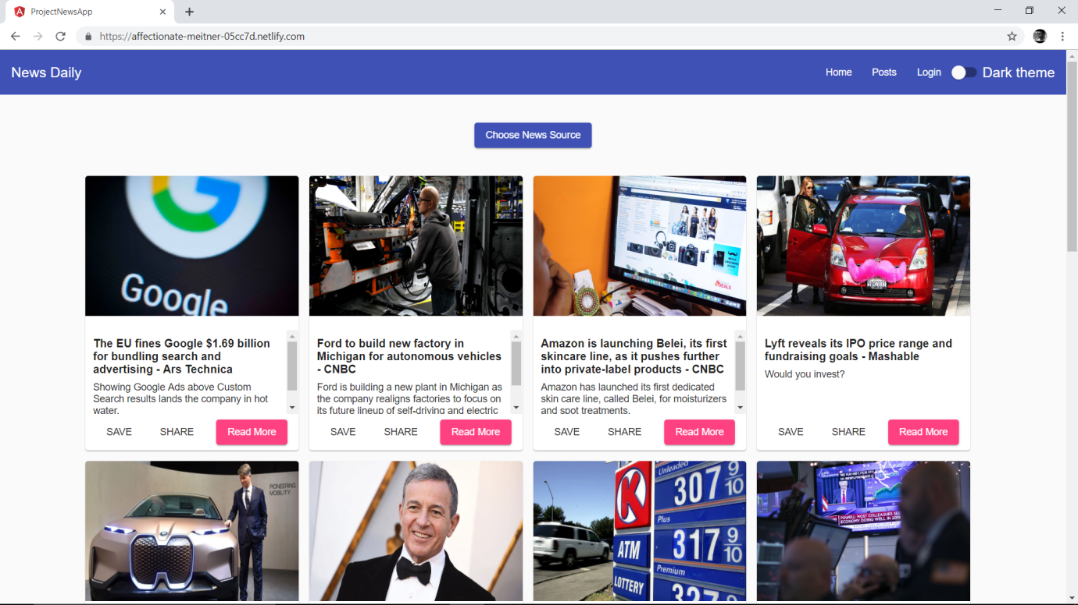

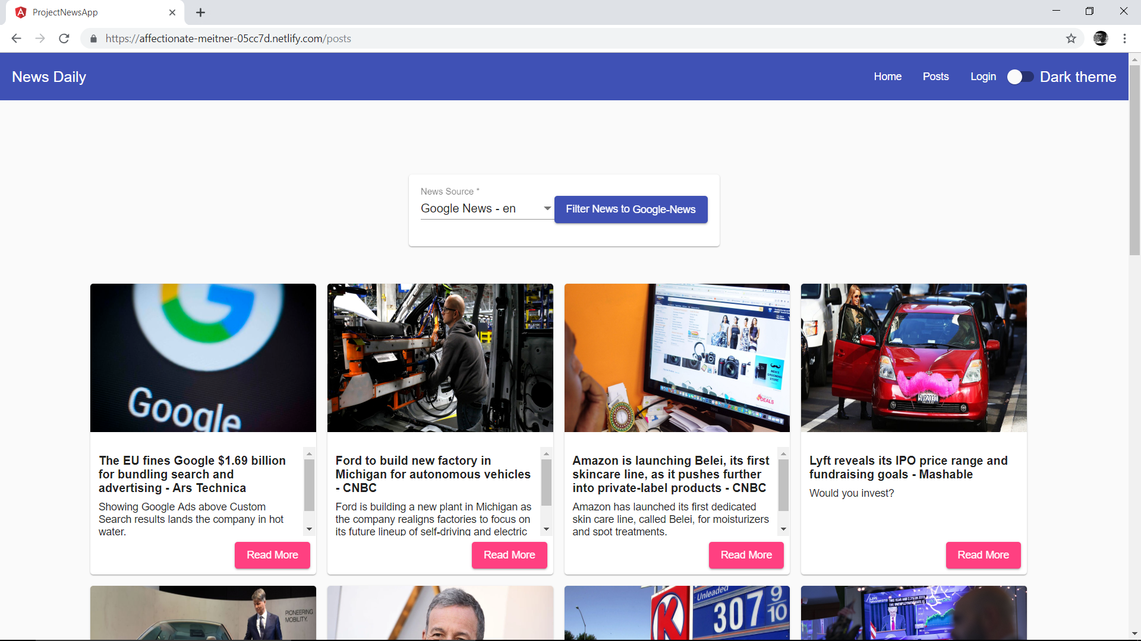

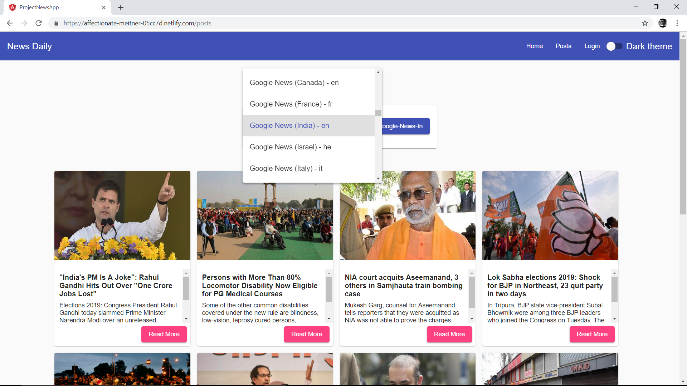

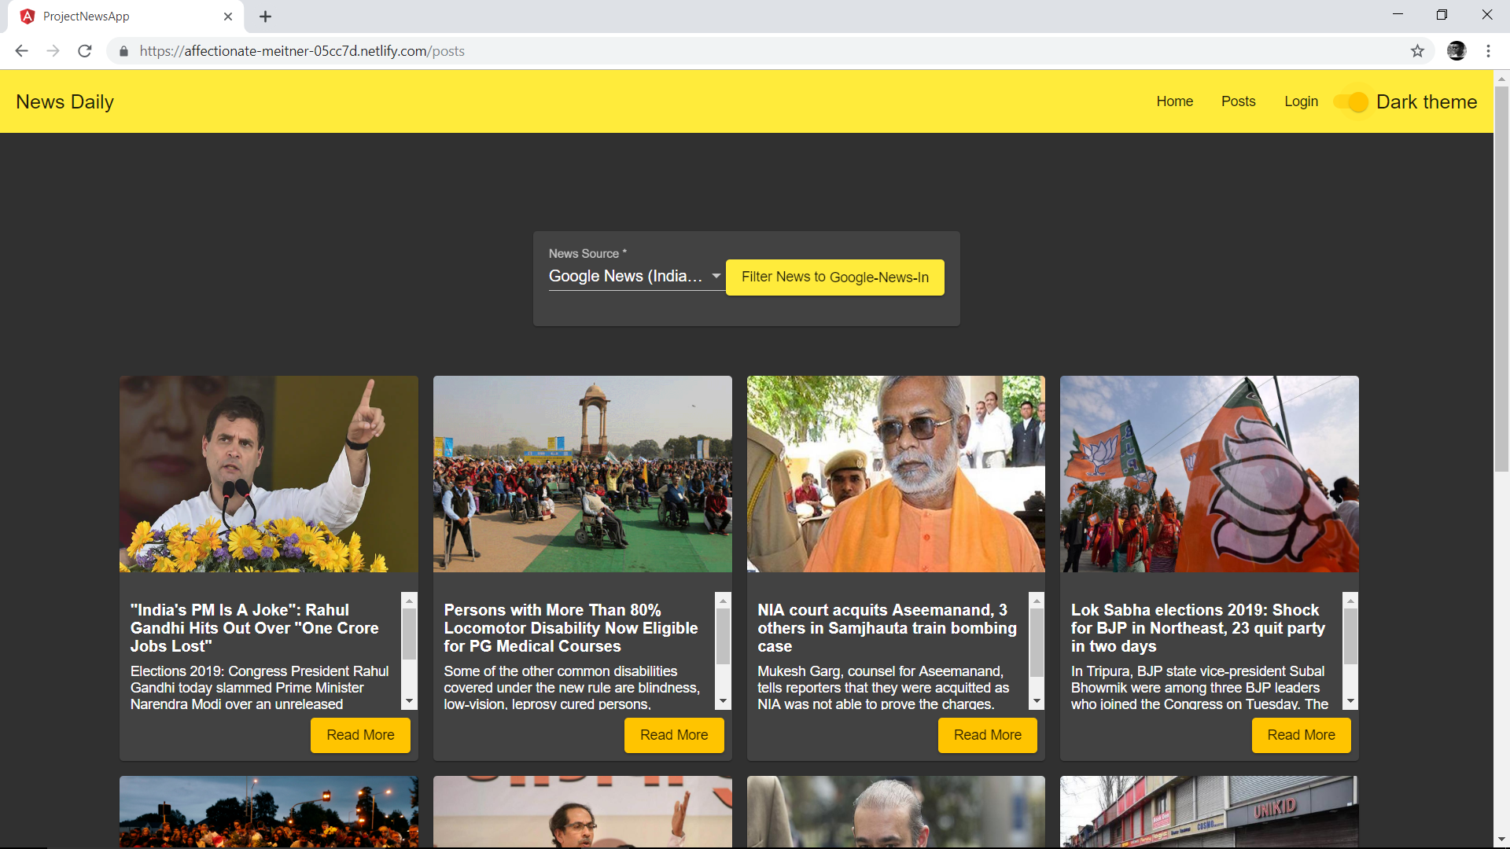

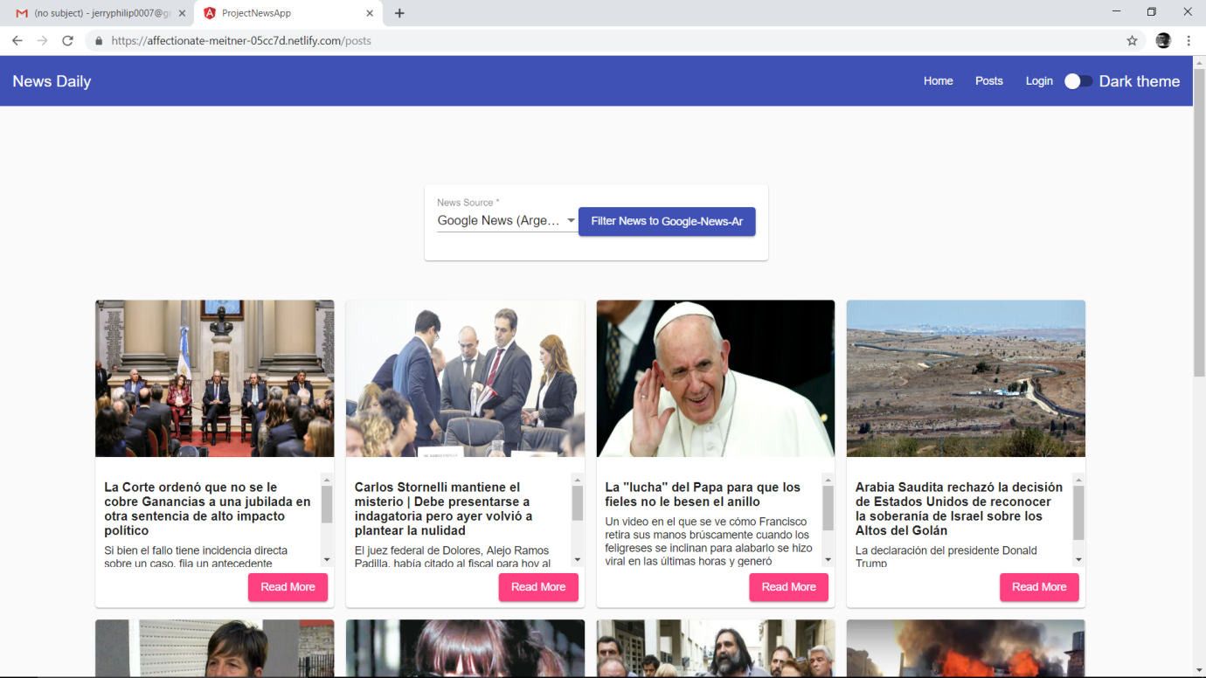

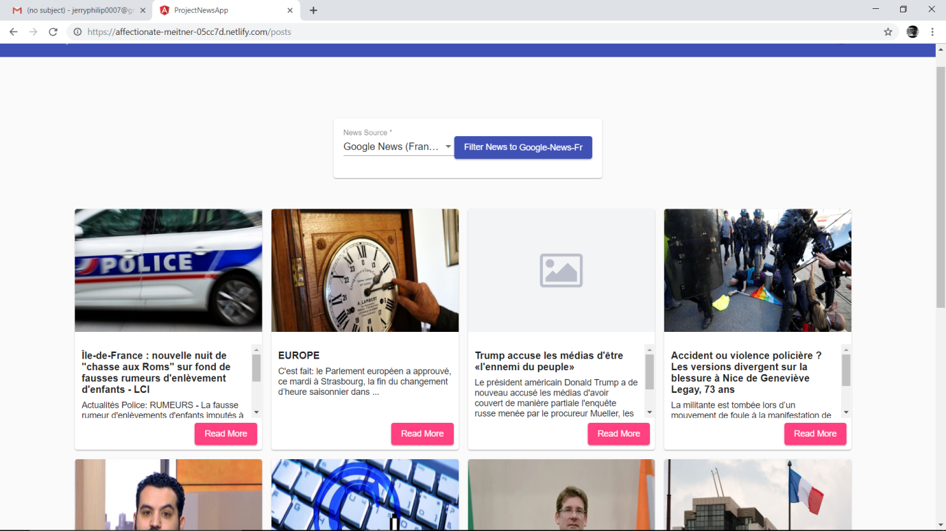

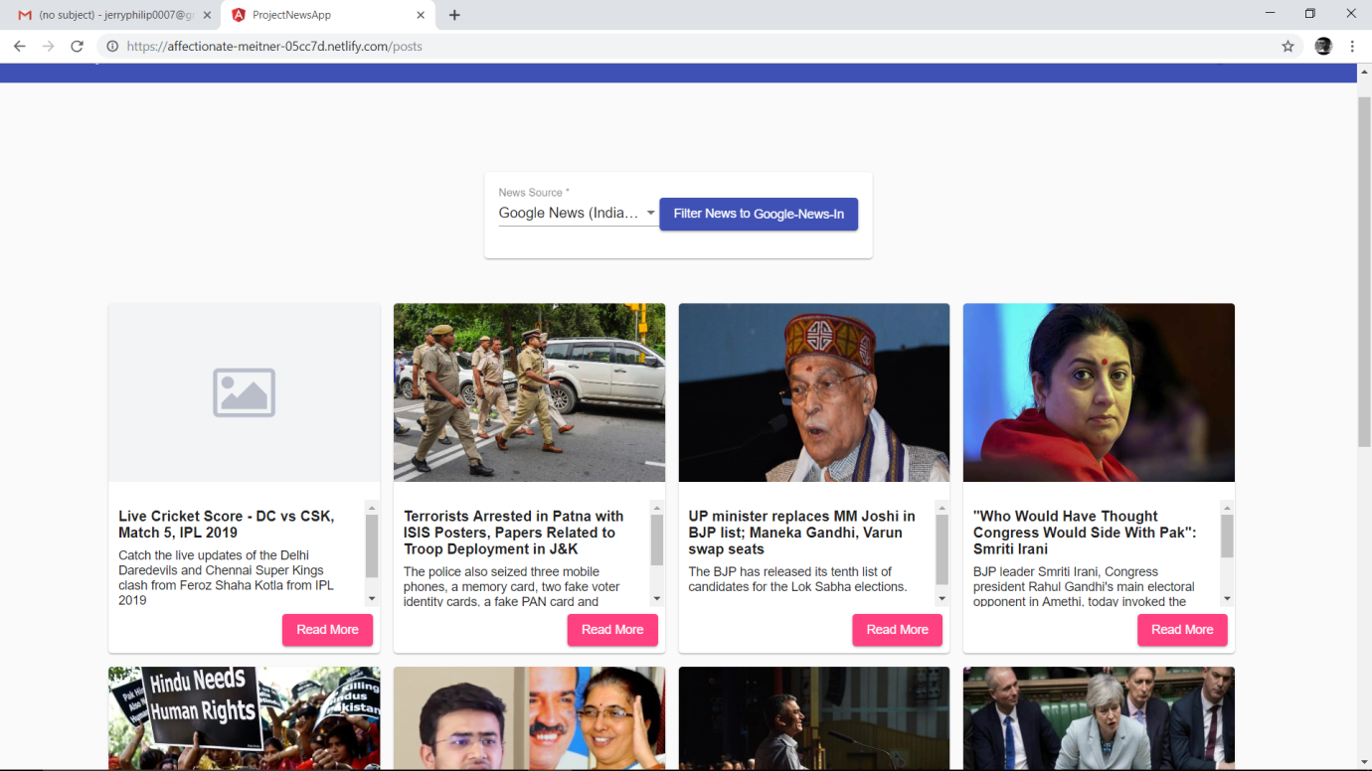

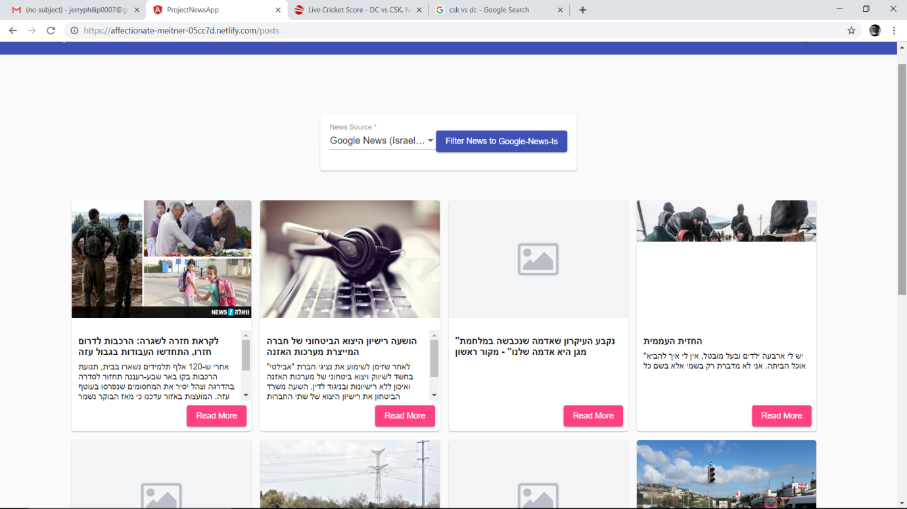

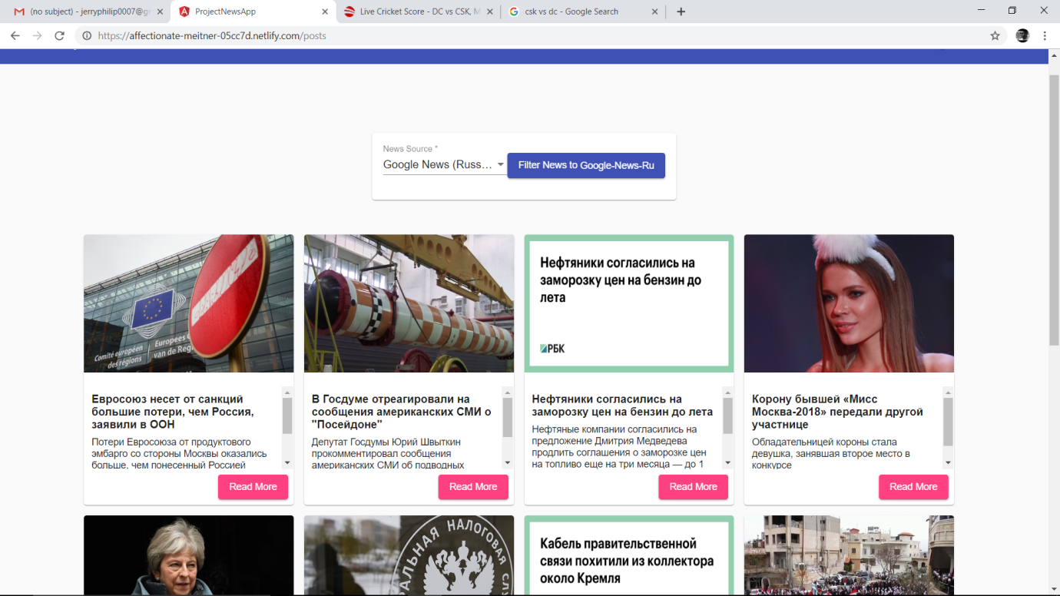

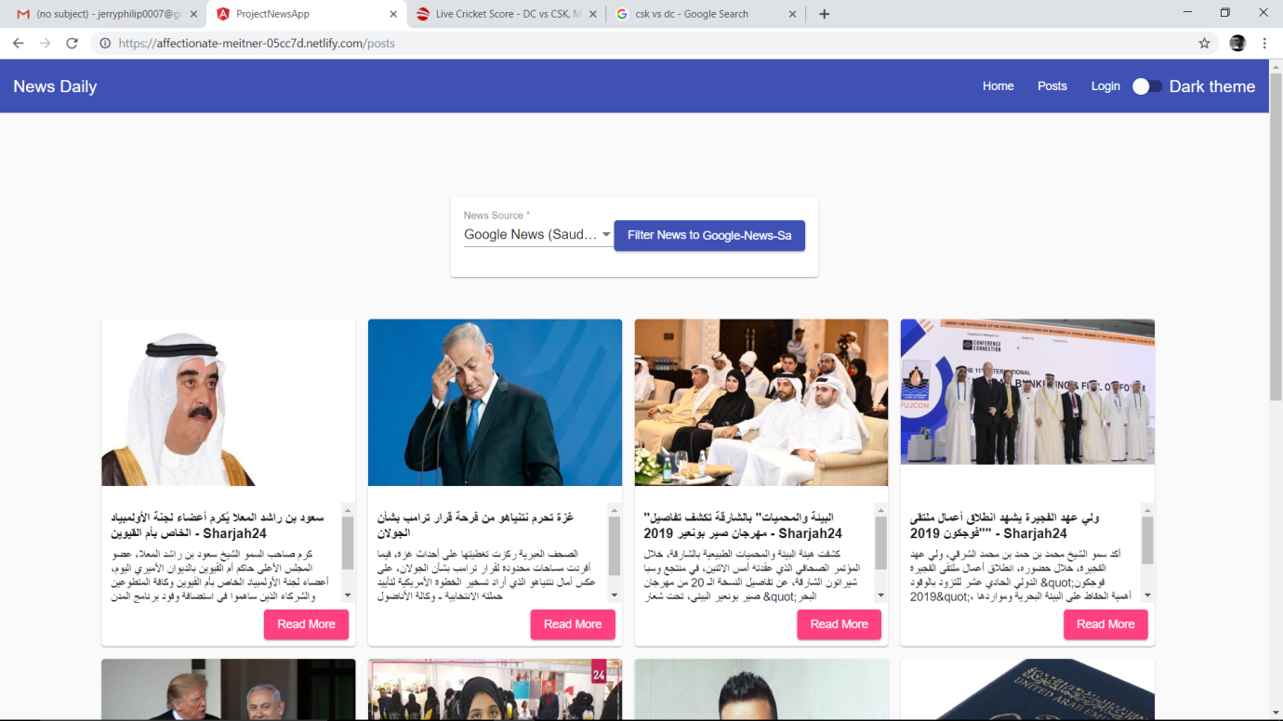

**BIBILOGRAPHY**

1. “*Pro Angular js*” by Adam Freeman

2) “Learning AngularJS” by Brad Dayley.

3) www.google.com